The University of Azad Jammu and Kashmir, Muzaffarabad


Submitted to: Engr. Fahad Nisar

Course Title: Software Configuration Management

Course Code: ST-1206

Name: Muhammad Usman Lodhi

Roll No: 2025-SET-36

Session: 2025-29

Semester: 2nd

Lab Task No: 01

Bachelors of science in Software Engineering Technology
Department of Software Engineering
Install Git And Configure your Identity settings

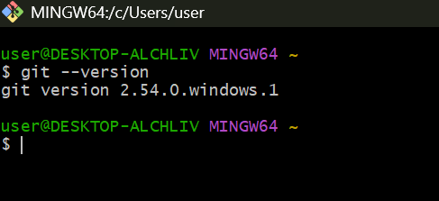
- Verifying Git Installation:

- Set User Name in Git:
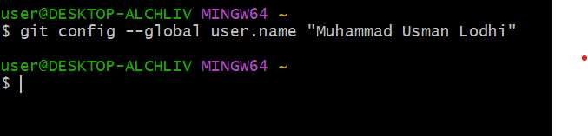

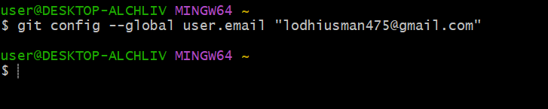
- Set User Name in Git:

- Set Default Editor:
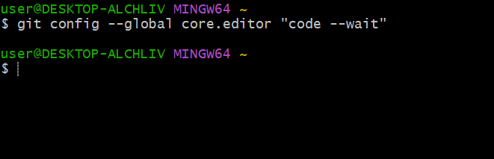

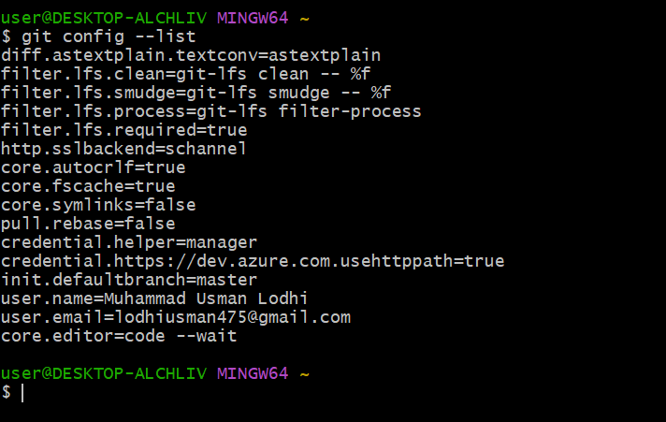
- Verifying all Configuration:

The End

